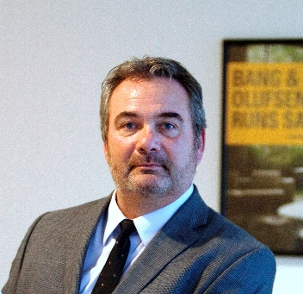

Larry Allen Morgan, CFM, SFP, FMP

Mr. Morgan is a dynamic, accomplished corporate asset and service delivery operations
professional with over 35 years of progressive, tangible and thought leadership accomplishments
with substantial relationships within the corporate and commercial real estate industry.

His primary core competencies are in the areas of strategic facilities and workplace experience planning, tactical operations, sustainability initiatives, capital project management, risk management integration of emerging technologies, commercial real estate management and quality programs all with focus on creating and managing an optimal built environment.

With his depth and breadth of experience he provides innovative and new approaches in achieving service level improvements across multiple platforms by applying design thinking, proprietary creativity, and having the ability to grasp and apply complex intellectual abstractions

Mr. Morgan is a past IFMA chapter president, member of the International Facilities
Management Association (IFMA) Board of Directors , 2017 IFMA Distinguished Member of the
Year and a highly regarded and sought after IFMA global master instructor. He brings a unique
insight to the training and education process required to achieve maximum return on human
capital investments.

Mr. Morgan is a guest lecturer, presenter and consultant on critical and current Facilities topics
for many organizations and companies globally.

